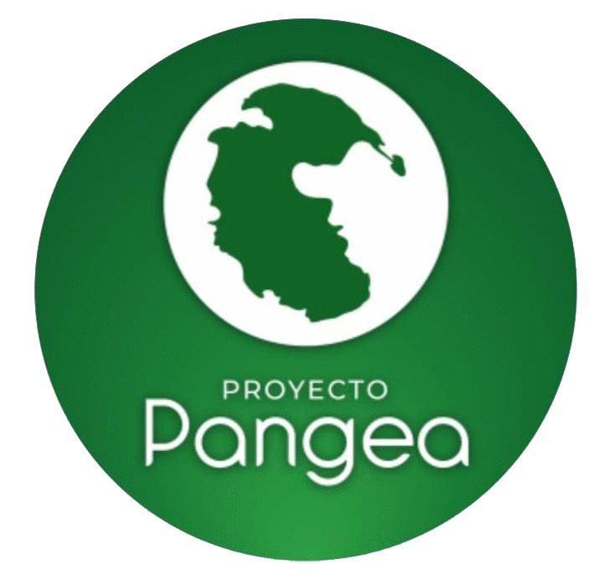
Did you know that over 50% of world’s GDP depends on nature?
That’s why I created Project Pangea, an online tool that everybody can use to access high quality slow food products with a smaller impact on the environment.
In the age we are living, we know thanks to the available information that an important parto f the climate change is caused by the mismanagement of financial resources. Because of this, I find myself in the moral duty to do my part by creating Project Pangea. This online tool will improve the transparency of the supply chain.
It’s time to change: Let’s get a deforestation-free supply chain.

ONLINE TOOL
This online tool aims to promote the use of shortcuts to avoid the intermediaries’ action, the local agriculture, the art of restaurant business and the strengthen of local economy.
The online tool provides a networking platform which is enviromentally friendly since it promotes the Exchange between consumers and supliers of agricultural products.
In order to achieve our goal, Project Pangea will guide the users and teach them how to use confidently the online tool.
Thus, they will feel rewarded because they will be becoming better professionals and will be making the world a better place to live.

Nowadays you just have to go to the supermarket to find a wide variety of food ready to be consumed. This can make a lot of people’s lives easier but how many of us don’t know where all these products ultimately come from?

WHAT IS PROJECT PANGEA?
The goal of PROJECT PANGEA is to raise people’s awareness about the food they are eating: from its production to its consumption. We aim to minimise the number of intermediaries in order to promote the contact between farmers and consumers. Furthermore, we want to bring home people the marvellous process of agriculture so they can appreciate the work of farmers and the importance of a sustainable way of farming.

P = Production / Professionals: Creations and management of projects for restaurants, professionals of Gastronomy and other (i.e. schools, dormitories, hotels…)
A = Agriculture: Dissemination and support of reponsible farming projects that are environmentally and community friendly.
N = Nutrition: Education for a conscious nutrition in order to teach people to eat in a healthy and responsible way.
G = Gastronomy/ Management
E = Education: Teaching people about processes and History of farming and agriculture and the benefits of certain ingredients.
A = Action.

HOW DOES IT WORK?

PHASE 1. Start your own vegetable garden

Have you got an underused garden? A gloomy terrace? Or maybe a little bit of room at home? Use it to grow your own edible plants (basil, rosemary, oregano, tomatoes, peppers…)
Growing vegetables for your own consumption will give you and your family a different point of view about the food production process. You will realize how much love and dedication lies behind this process and, at the same time, you will find very rewarding to be able to create something with your own hands.

How does it work?
We will send you everything you need to start growing your favourite plants: the materials needed to build the garden according to the available space, dirt, fertilizer and the seeds or the already grown plant.

More advantages:
You will get access to all the courses you will need to learn to take care of your plants so they can have a long and happy life.
Recipes to cook and experiment with your plants, for example, prepare and bottle your own sauces, canned food, soap and natural essences
You will join a community of people where other beginner farmers like you could exchange your products and share your experiences.

PHASE 2. Adopt a farmer/a vegetable garden
Can you imagine joining other people to help supporting and maintaining a vegetable garden and the people who take care of it?
Farmers need our supponrt to keep creating high quality products that affect positively the environment.

How does it work?
Thanks to Project PANGEA you will be able to meet people who work the land and learn about the effort they put to make this activity sustainable.
In exchange, every month you will receive at home a box with fresh season products grown by the farmers. This way you help small producers near you who are committed with the environment. Moreover, you and your family will be eating natural, toxic substance-free products.

More advantages:
You will still be geting a variety of seasonal recipes to cook at home according to your necessities.
We will inform you about the properties and other interesting data of the food you will be receiving.
In addition, we will organize a meeting so you and your family will have the chance to meet personally the farmer who is behind the garden you are eating from and help them in harvesting or sowing.

PHASE 3. PANGEA for professionals

Are you a chef or a restaurant manager? Thanks to us you will be able to find a land or a farmer with whom you can start growing the food you want to serve in your restaurant. Your clients will appreciate your serving freshly gathered and healthy products “grown at home”.
Are you a farmer who wants to boost the way of producing 100% ecological products? Our experts will help you carry on an ecological agriculture which will make your plants grow healthy without the help of chemical products that may ruin the soil.
Are you in charge of a school, a home for the elderly or any other kind of social institution? We help you build a vegetable garden in you building or near it so people can take care of it and learn about the process of growing food.

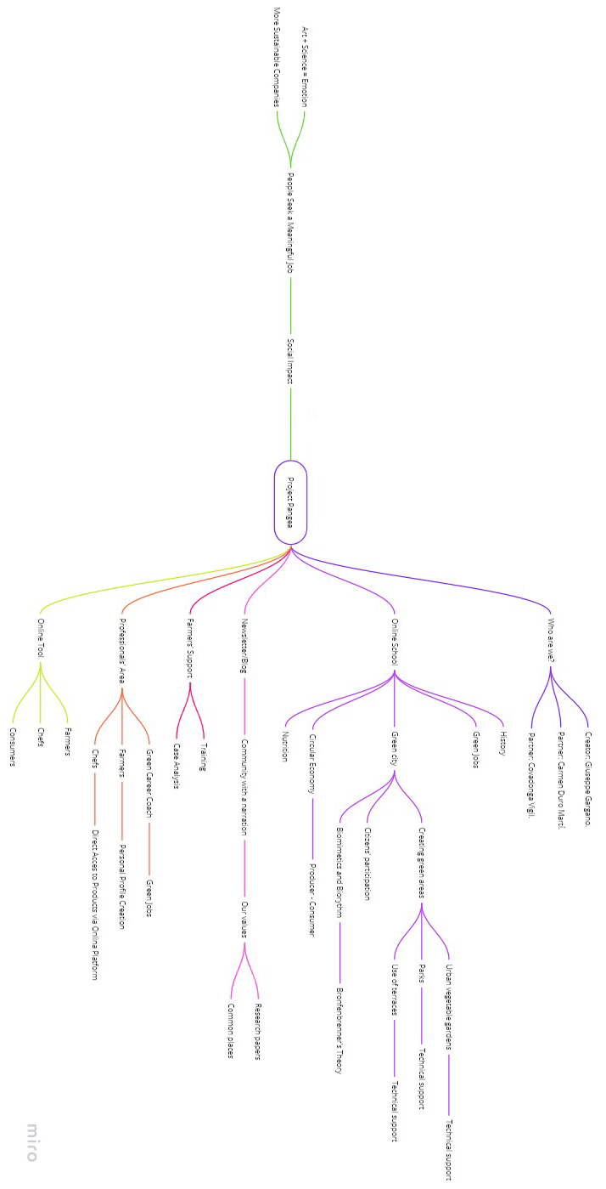

"Ideas are cheap. It's only what you do with them that counts"

—Isaac Asimov

